**Deliverable 4**

**Team ThoseKoolKidz W18A**

Harsimran Saini

Arindam Mukherjee

Meilin Huang

Yulan Guo

Table of Contents

Summary of Changes: 3

Coded Beta Prototype: 5

Appendix: 6

# Summary of Changes:

|  |  |  |  |  |  |  |
| --- | --- | --- | --- | --- | --- | --- |
| **#** | **Severity 0 (low) - 4 (high)** | **Principle** | **Description of issue** | **Effects on usability goals** | **Effects on user experience goals** | **Changes made** |
| 1 | 0 | Consistency and Standards (Heuristics) | Consistency and standards help users understand what they could do since they can build on prior knowledge from inside or outside our system.  After creating an account ('Signing Up') the user expects to be automatically Signed In. However, our system takes the user back to log in and expects the user to log in again (See Appendix A1). This creates a repetitive experience for the user. | Efficiency | Repetitive | After successfully creating an account ('Signing Up') the user is automatically taken to the home page (See Appendix A2). |
| 2 | 1 | Aesthetic and minimalistic design (Heuristics) | Aesthetic and minimalistic design refers to designing the screens in a way to avoid providing information that is irrelevant or rarely needed. This will decrease cognitive load (of searching) and allow the user to understand the main functions of the website.  On the 'Study Tools' screen there are 2 'Add' buttons (one at the top right and one at the bottom right – See Appendix B1). Having 2 different buttons for the same task is repetitive and confusing for the user. | Learnability | Confusing | Removed the top right add button as the one on the bottom right is consistent across other screens (See Appendix B2). |
| 3 | 2 | Error Prevention | Error prevention principle refers to adding checks into the system and providing feedback for the user to make it easier for them to recognise errors. By preventing errors from happening before they occur, this in turn allows users to ensure that the interface gives them a chance to resolve their mistakes before creating one.  On the “My courses” section, when a user clicks on a course that they have already joined and click the leave button, it automatically gets them to leave the channel (See Appendix C1). This negatively affects the safety of the system. | Safety | Dangerous | Now the system displays a confirmation screen in case a user had mistakenly clicked the leave button (Appendix C2). |
| 4 | 1 | Visibility (Design Principles) | Visibility refers to how the visual design provides clues about how to interact with the system.  The '▷' button on the tasks of the study tools screen is confusing in its functionality. User is not sure what '▷'-ing a task means (See Appendix D1). | Learnability | Frustrating | Replacing '▷' with 'Start a timer' (See Appendix D2). |
| 5 | 1 | Mapping (Design Principle) | Mapping refers to relationship between controls and their movements and the results in the world.  As availability is a range user expects it to be mapped as such. Having only 1 time to represent availability is confusing for the user (See Appendix E1). | Learnability | Confusing | Change the mapping to a range like Google Calendar. Essentially putting times in the top left corner instead of centre (See Appendix E2). |
| 6 | 1 | Consistency and Standards (Heuristics) | The system assumes the user is unavailable unless otherwise stated. This goes against convention of other popular systems, i.e.: Google Calendar, that assume users to be available unless otherwise stated. | Efficiency | Frustrating | The user should automatically be marked as available if they do not put in whether they are available or not. (See Appendix F1). |
| 7 | 3 | Visibility (Design Principles) | The slider on the create task (Study tools screen) is confusing in its functionality. As it does not have a label (See Appendix G1). | Effectiveness | Confusing | Added a label for the slider (See Appendix G2). |
| 8 | 1 | Error Prevention and Minimalist Design (Heuristics) | The headers in the availability section have redundant information and can be shortened. The search bar was confusing to users, as users were unsure of what it did (See Appendix H1). | Efficiency | Repetitive and Confusing | Changed tab names from “My Availability” and “Group Availability” to “Personal” and “Group”. Changed search bar text to make its function clearer. (See Appendix H2) |
| 9 | 1 | Minimalist Design (Heuristics) | The legend in group availabilities has redundant information. (See Appendix I1). | Efficiency | Repetitive | Removed legend. (See Appendix I2). |

# Coded Beta Prototype:

Link to our coded beta prototype: <https://nw-syd-gitlab.cseunsw.tech/z5208912/comp4511-study-sphere>

Please find instructions on setup in README.md.

# Appendix:

## A1: Sign-up to login

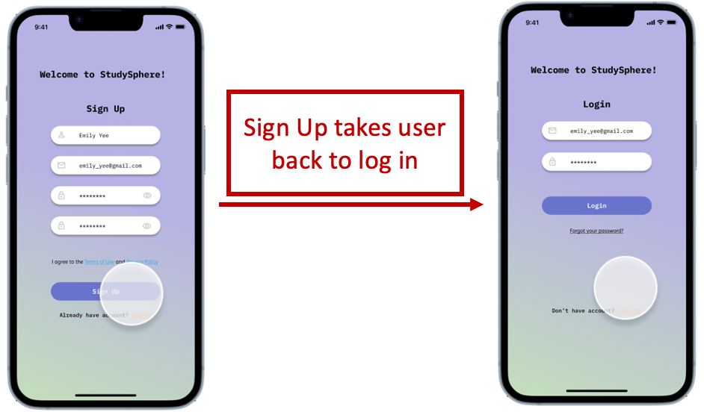

## A2: Sign-up to login fixed

## B1: Double the Add buttons

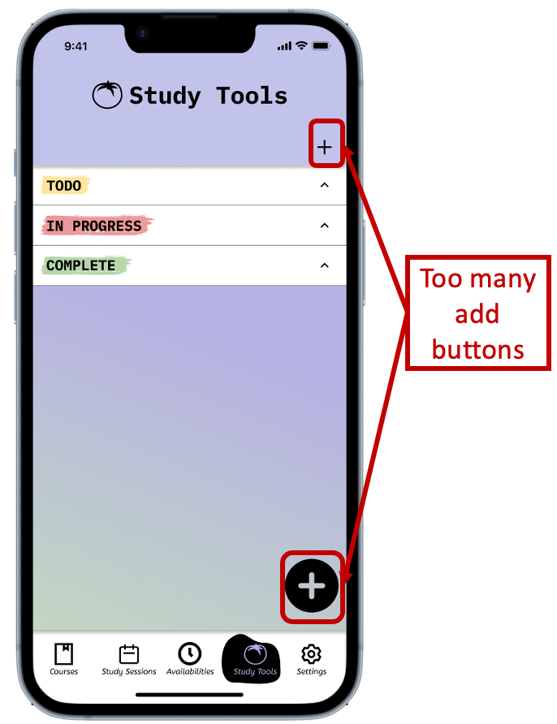

## B2: Double the Add buttons fixed

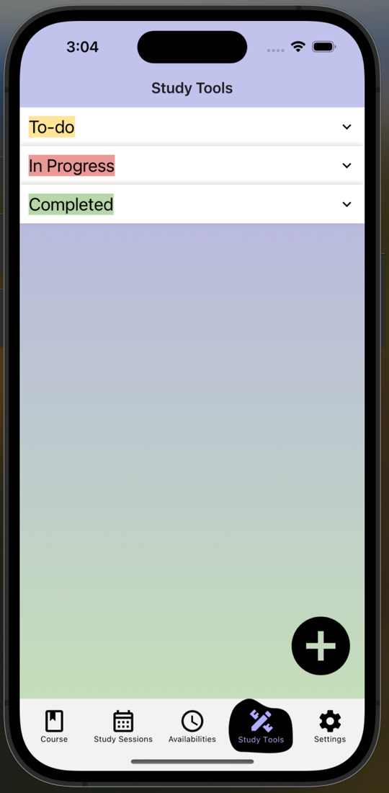

## C1: Error message on leaving course/class

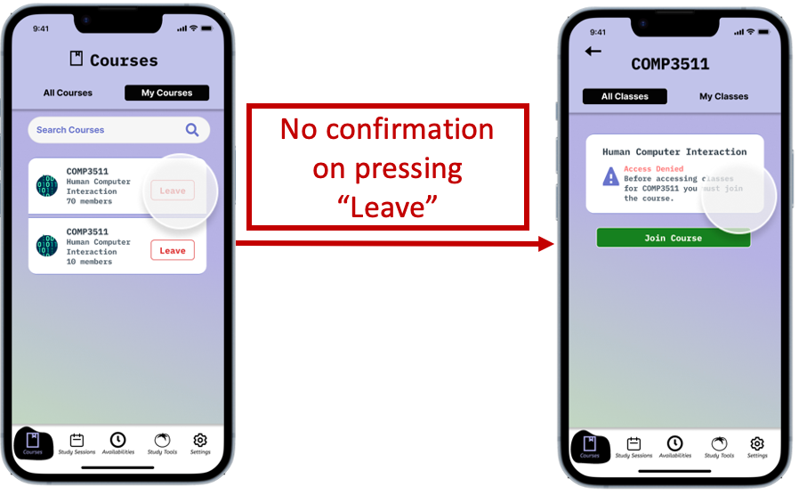

## C2: Error message on leaving course/class fixed

## D1: Start Timer

## D2: Start Timer fixed

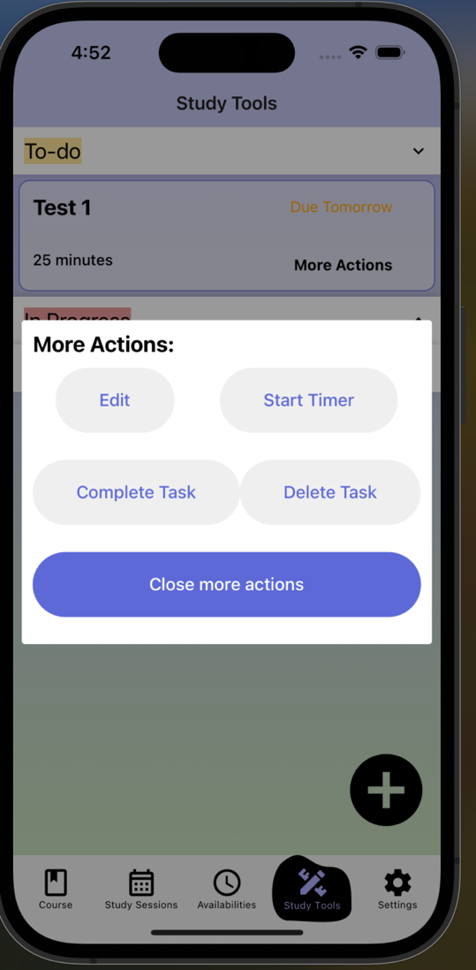

## E1: Calendar times

## E2: Calendar times fixed

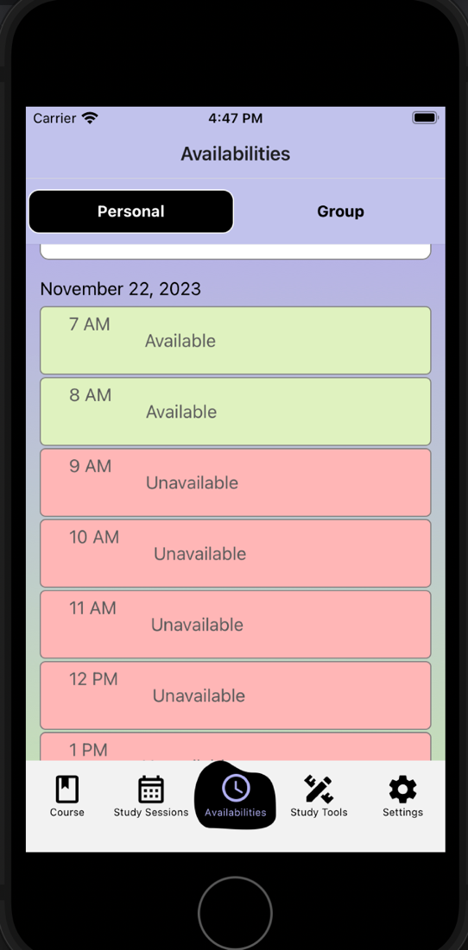

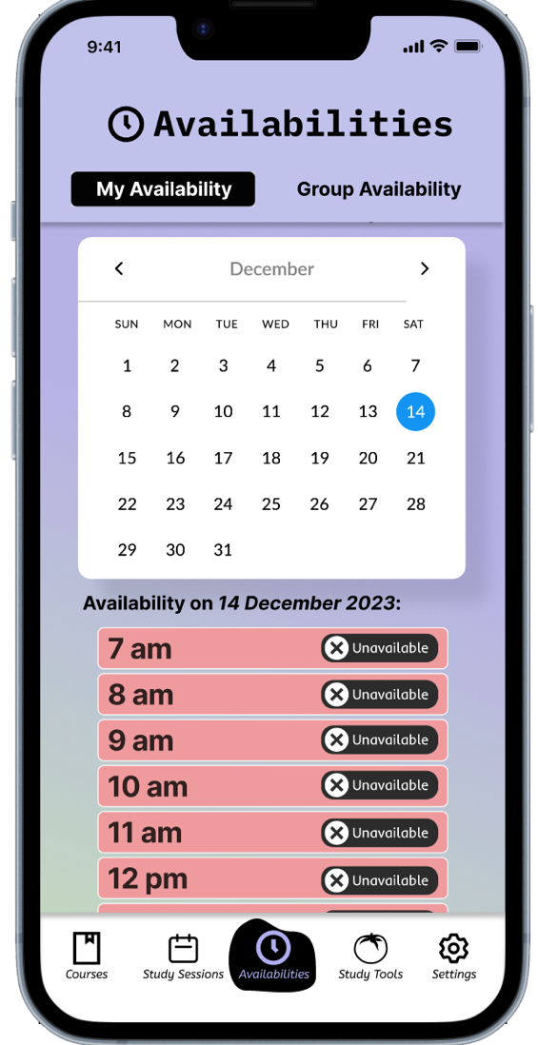

## F2: Available unless otherwise stated fixed

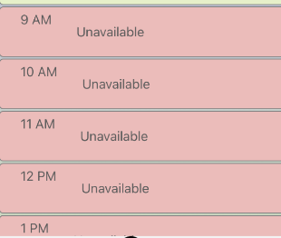

## G1: Slider label

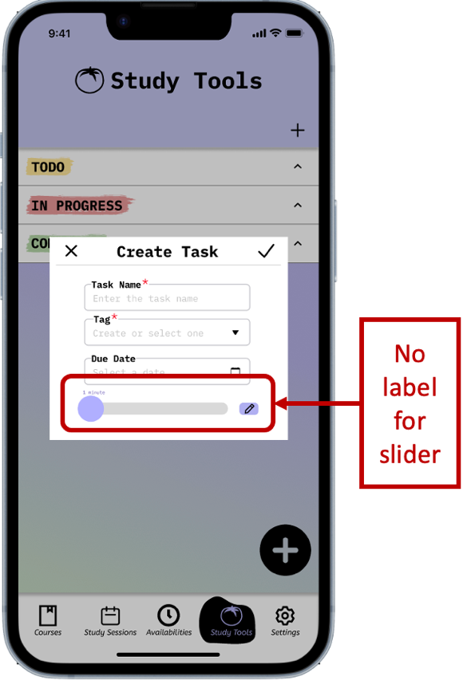

## G2: Slider label fixed

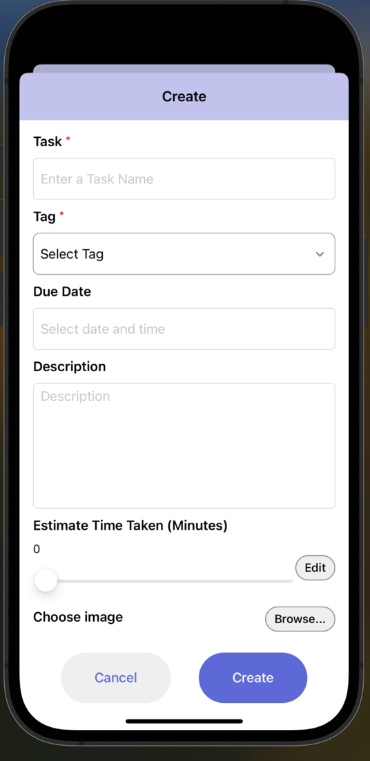

## H1: Tab Names and Search Bar

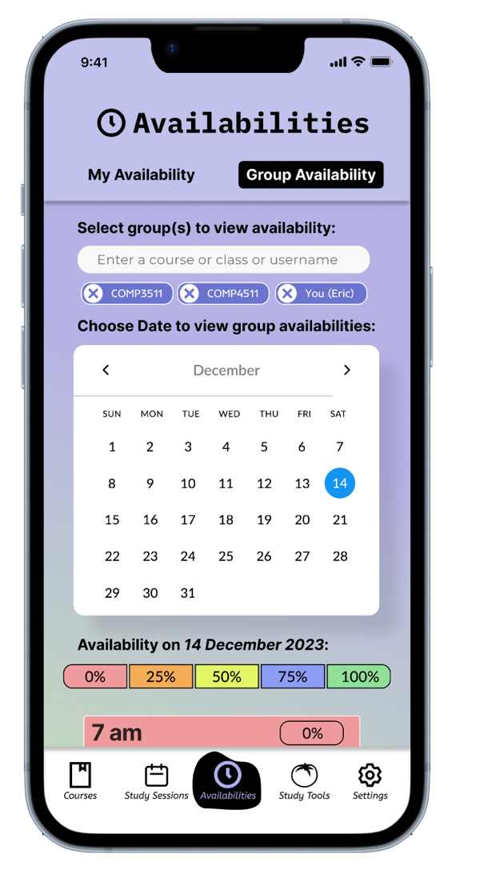

## H2: Tab names and Search Bar Fixed

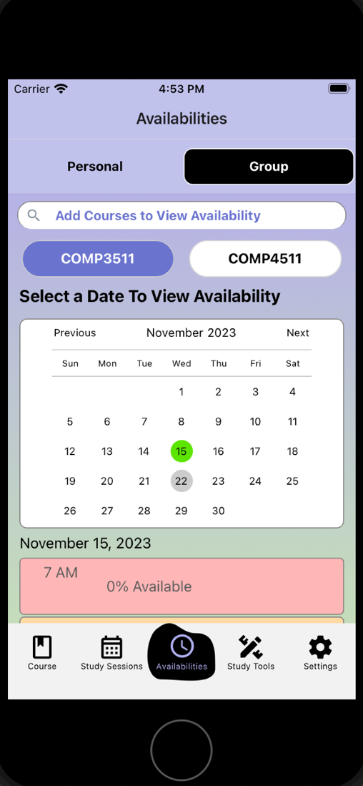

## I1: Legend



## I2: Removed Legend

